**Test Driven Development Report**

The video demonstrates a test to check whether the output containing information of hospitals details, prices of the procedure and distance to the facility is sorted in ascending order according to the distance between the user inputted location and each of the hospitals that provide the procedure. Since one of the constraints of the user is the distance to the facility, this is an important piece of functionality that addresses that specific need of the user. If price is not as much of a concern to the user as distance, it is important for the user to see the hospitals closest to them that they can go to seek treatment.   
Before writing the code for this function, it is important to create a test to ensure that the function works as is expected. We have used the xunit unit testing framework to assist with that task.  
First step of creating a test plan for this function is to know the expected output and input. The input passed into the function is all relevant information of the hospitals that fit the procedure search criteria of the user, price of the procedure and distance in the form of a list of string arrays. The program should display this output to the user in order of hospitals closest to them first.  
Since the field that we are concerned with is the distance, we can sort this list using the System.linq namespace to order the list based on a specific array element (in this case 12). The best possible way to confirm that this order function works as expected is to compare the output of this function with an already existing pre-sorted list, which is what the test chosen above does. The test function contains an expected list which is a pre -sorted list with the elements in the right order and compares them to the list that the sort function returns. If these two lists are equal, the test passes.

Evidence of Testing

Tests and test plans for the project can be found on Github.

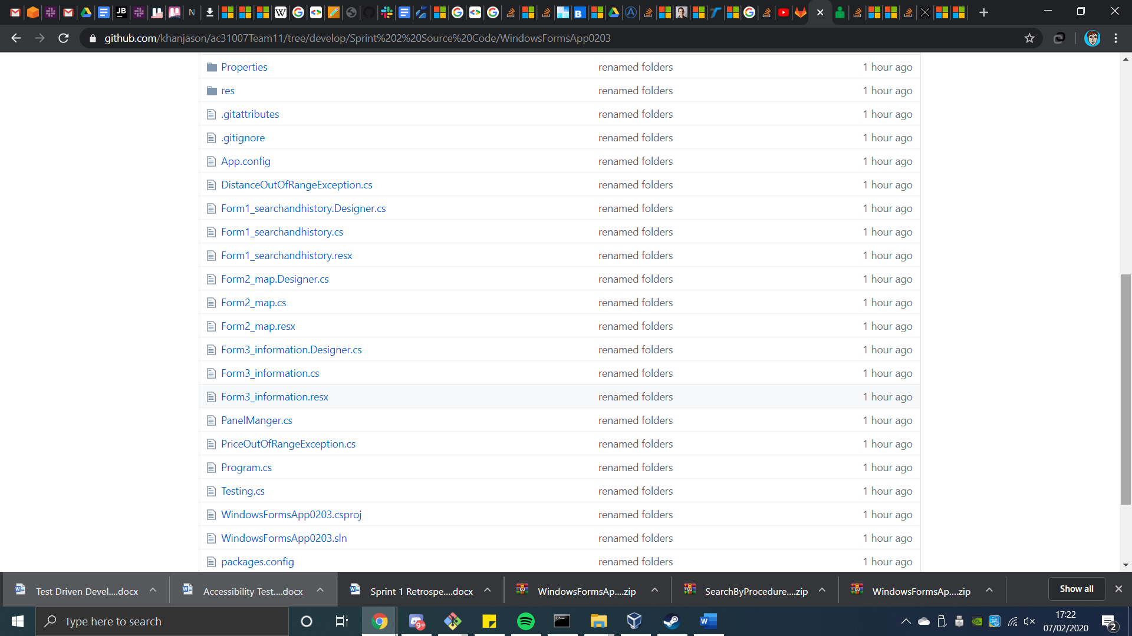

Testing.cs in source code is for testing adding hospitals to the map.

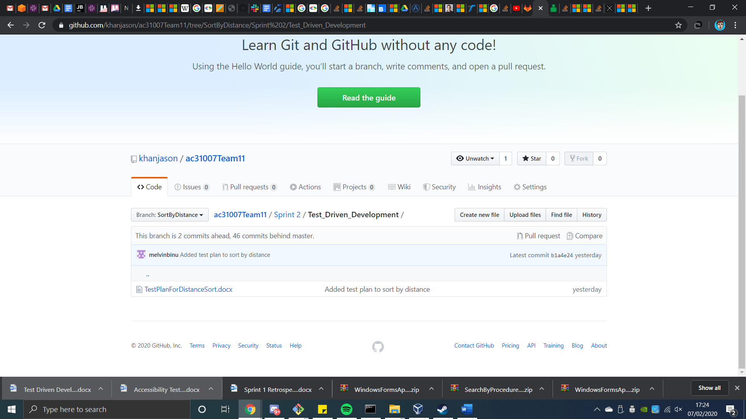

Test plan for sorting by distance, on branch SortbyDistance. Test code can be found in Source Code/SortByDistance.zip

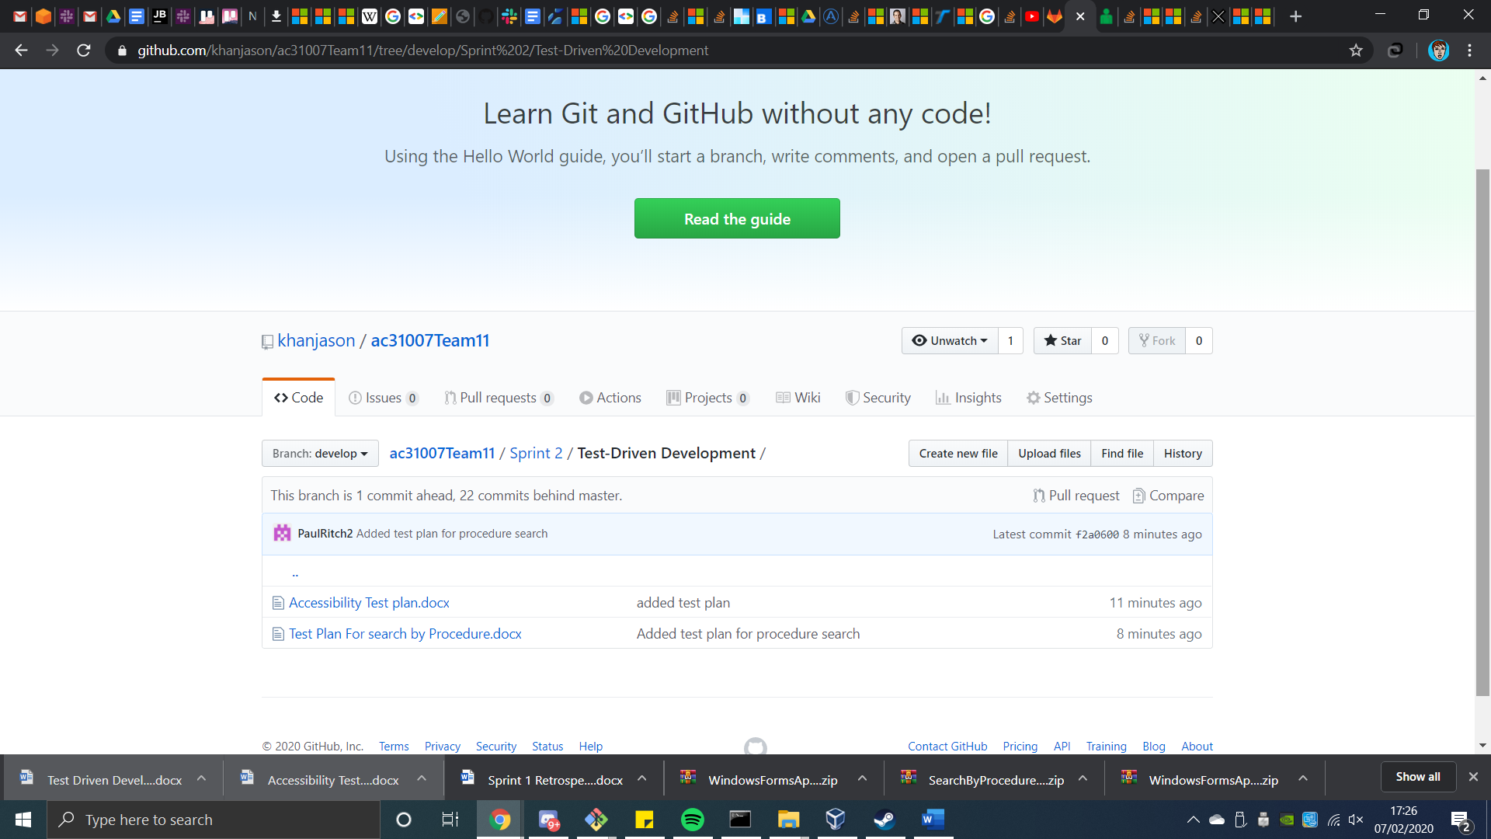

Test plans in /Test-Driven Development, and tests for searching by procedure is in source code.